Professional Development: Unit Creation and Intro to Templates
Speaker: Ms. Debbie Liberi, RET Resource Person and Grant Coordinator
Date: Tuesday, June 20th, 2017
Time: 1:00-2:30 PM
Venue: University of Cincinnati, Swift Hall, Room 516

Prepared by:
Ryan Wright, Ryle High School, Union, KY
RET Participant for Project #3: “Bio-inspired optimization of the travelling salesmen problem”

This session was given by Ms. Debbie Liberi, RET Resource Person on Tuesday, June 20th, 2017 from 1-2:30 PM at the University of Cincinnati in Swift Hall, room 516. Debbie Liberi currently serves as the District Coordinator for the CEEMS grant at UC and as Coordinator for the RET Program. She earned BA in Biology at Wittenberg University and a Masters in Secondary Educations from UC, as well as, a Masters in Library and Information Science from Kent State University. She was a middle school science teacher and high school librarian for 35 years with CPS. From 2000-2010, Debbie was a National Board Certified Teacher in Early Adolescence Science. She also served as a lead teacher in various mentoring roles for CPS. In addition, Debbie has served as an adjunct faculty in the Teachers College at UC and at Xavier University. Prior to beginning the presentation, Ms. Liberi passed out several handouts to everyone, including feedback forms, copies of the templates, and checklists.
Ms. Liberi began her presentation by asking the class to text a code to a number to register with Poll Everywhere. She then went over the objectives of today’s presentation and stressed that this would be mostly logistical in nature. She then asked all attendees to complete a pre-assessment quiz (Fig.1) to determine what the classes understanding of the unit expectations was before beginning the presentation.
The first main topic covered in this presentation was the content that was to be included in the units that needed to be submitted. Ms. Liberi went over what exactly was to be included in the unit in terms of lessons (2) and activities (2) within those lessons (Fig.2). This was section 7 of the unit template. This was followed with a look at a specific example of what the Unit/Lesson/Activity writeup would look like, which includes information about each individual lesson, names of the activities, a timetable of how long each will take, and direct ties to the CBL and EDP processes. This part of the presentation was concluded with questions from the attendees, as several teachers had questions about the topic. Ms. Liberi provided answers to every question before moving on.
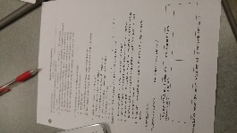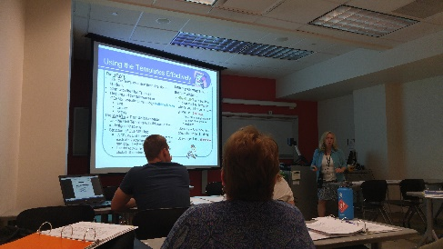
Fig.1: Taking the pre-assessment Fig.2: Discussing Required Unit Content
Next, Ms. Liberi asked the RET teachers to read sections 1-5 of the unit template on their own. Highlighters were distributed and teachers were told to highlight any sections where they thought extra guidance might be needed. She then once again opened the discussion for questions about what everyone may have highlighted, providing clarification about things that they were unsure of before moving on. Ms. Liberi provided several examples of units from past RET years to show all the different approaches that could be taken in doing these units. She then transitioned into showing the glossary/vocabulary handout to the teachers, which contained several important terms used throughout the templates to help teachers understand what is being asked of them. This portion of the presentation ended with a short Scavenger Hunt activity, where teachers were asked to scan through the template materials to find answers to a series of given questions about how to do the unit template (Fig.3).
Ms. Liberi then shifted the presentation towards more of a focus on CBL and EDP, specifically about how to regard information to help demonstrate that the unit involves both processes. She specifically mentioned, for example, the importance of having students document their planning stages and not just letting them jump right into building a product. She stressed being deliberate about ensuring that students work their way through the process step-by-step. Teachers were then asked to practice this using the previously given example by having them write out the challenge, guiding questions, constraints, connections to the EDP, and example assessments that may go with it (Fig.4). These results were then discussed and broken down as a group.
Finally, the presentation was ended with a short quiz through Poll Everywhere (which everyone had registered for earlier). This quiz was the same as the pre-assessment quiz, and answers were discussed once everyone had sent their answers in to the website.
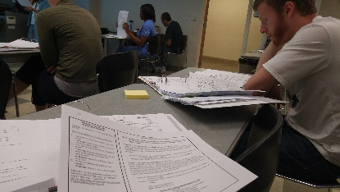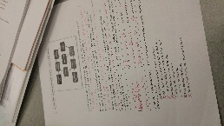
Fig.3: Completing the Scavenger Hunt Fig.4: Connecting to EDP

